**LESSON 2: INTRODUCTION TO HTML**

**OBJECTIVES:** By the end of this lesson, students will be able to:

<>Understand the basic structure of an HTML document.

<>Create a simple web page using HTML tags.

<>Understand the purpose and usage of common HTML tags.

****Basic Structure of HTML****

**<!DOCTYPE html>**: This declaration specifies the document type and version of HTML being used. In this case, it's HTML5, which is the latest version of HTML.

**<html>**: The root element of an HTML document. All other elements are nested within this element.

**<head>**: Contains meta-information about the document, such as character encoding, viewport settings, title, links to external stylesheets or scripts, and other meta-data.

**<meta charset="UTF-8">**: Specifies the character encoding for the document. UTF-8 is a widely used character encoding that supports a wide range of characters.

**<meta name="viewport" content="width=device-width, initial-scale=1.0">**: Sets the viewport properties for responsive web design. It ensures that the page adapts properly to different devices and screen sizes.

**<title>**: Defines the title of the document, which appears in the browser's title bar or tab.

**<body>**: Contains the main content of the document, including text, images, links, forms, and other elements that are visible to the user.

Here is a simple example:

*<!DOCTYPE html>*  *<!-- document type & version I.e HTML5 -->*

*<html lang="en"> <!-- lang attribute specify the language of the content -->*

*<head> <!--this is head, opening tag-->*

*<meta charset="UTF-8"> <!-- character encoding for the document -->*

*<meta name="viewport" content="width=device-width, initial-scale=1.0"> <!--* viewport properties-->

*<title>*My First HTML Document*</title> <!-- this is the title of document-->*

*</head> <!--this is head, closing tag-->*

*<body> <!--body, opening tag-->*

*<h1>*Hello, World!*</h1> <!--heading-->*

*<p>*This is a basic HTML document.*</p> <!--paragraph-->*

*</body> <!--body, closing tag-->*

*</html> <!--root element of html document-->*

Note: <!-- --> : is used to create comments within the code.Comments are not displayed on the web-page and are only visible in the html source code.

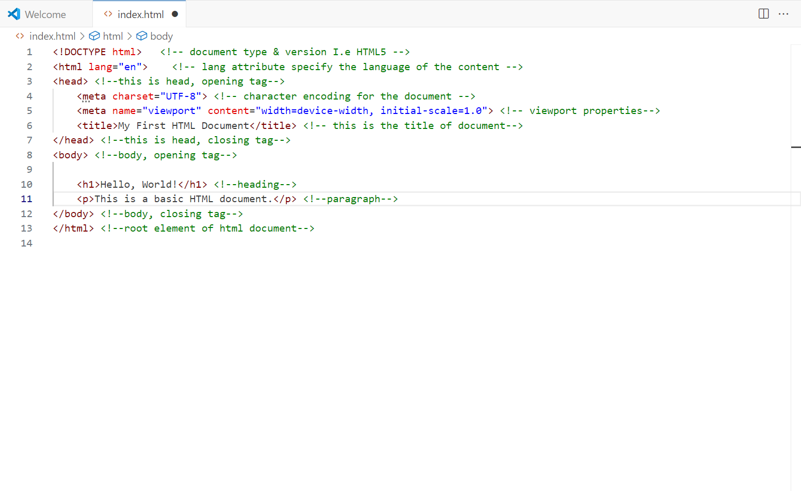

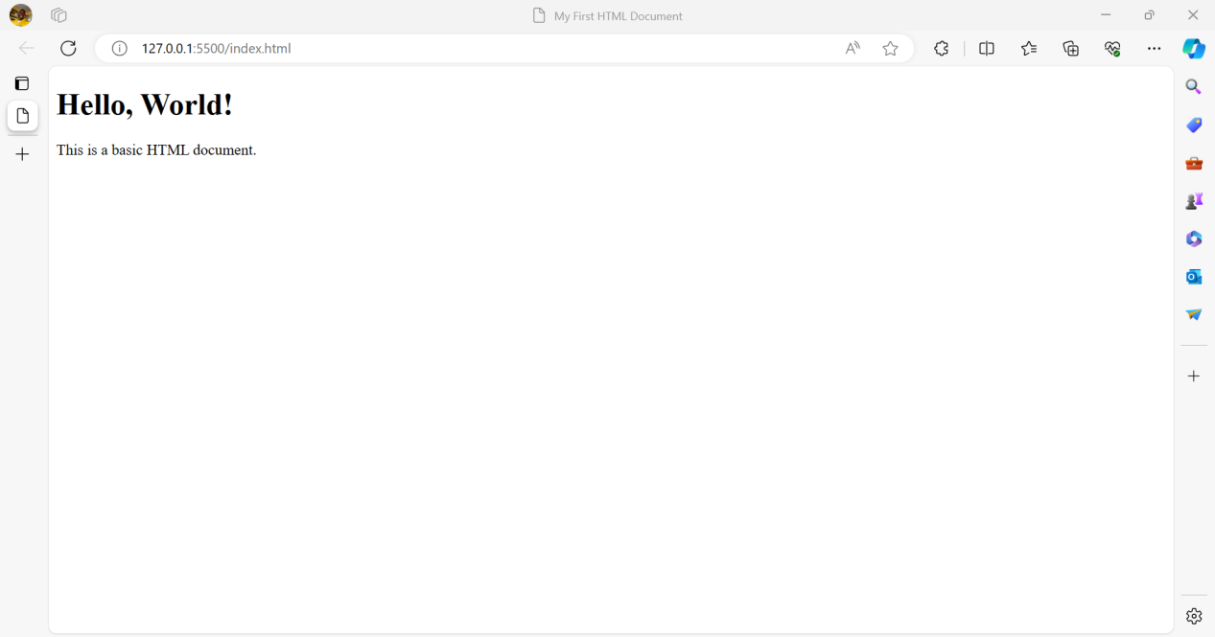

The above example helps you get core understanding of a html structure.